**2016 8 SCIENCE BIOLOGY ASSIGNMENT**

CELLS

[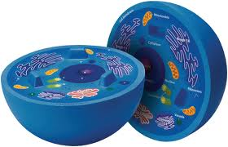](http://www.google.com.au/imgres?imgurl=http://www.crsd.org/cms/lib5/PA01000188/Centricity/Domain/741/Cell%20Diagram.jpg&imgrefurl=http://www.crsd.org/Page/27877&h=1009&w=1571&tbnid=Zboq5y-HNYRUXM:&zoom=1&q=cells&docid=1L04gdzyNGwFoM&ei=0cvaU_eLA4GE8gXyiILoCA&tbm=isch&ved=0CF8QMyg5MDk&iact=rc&uact=3&dur=462&page=2&start=27&ndsp=34)

Name:_________________ Teacher:____________

Form:_________________ Due date:___________

**Aim:** This assignment will allow you create your own plant or animal cell and find out about the history of cell discovery.

**Plagiarism**

You must write in your own words, not copy sentences word for word from another student or another source.

Plagiarising = instant zero on assignment and you will have to re-do it.

**Assessment policy**

Give me a sick note/legitimate reason from parent BEFORE due date = new negotiated due date.

One day late = -20% taken off mark

Two days late = -40% taken off mark

Three days late = mark of zero given

After three days, students are required to attend a detention and are still required to submit the assignment.

**If you are not at school the day this assignment is due, please email this booklet to your teacher with a photo of your cell model by 4pm on the due date.**

**Teacher email: __________________________@aranmore.wa.edu.au**

**Part one: create your own plant or animal cell**

**Materials:** these are some suggestions of materials you can use.

- Shoe box - Styrofoam pieces - Newspaper - Thread

- Cardboard box - Packing foam - Magazines - Crepe paper

- Tissue box - Buttons - Wool - Cotton wool

- Tissue paper - Large googely eyes - Felt - Plasticine

- Corrugated cardboard - Pop sticks - String - Sequins

- Glitter - Tooth picks - Wire - Small sticks

- Small pom-poms - Paint - Ice cream container - Coloured sticky tape

- Pipe cleaners - Tissue paper - Stickers - Cellophane

- Beads - Modelling clay - Honkey nuts - Small electrical items

- Dried pasta (from taken apart radio, tv. etc.)

**Guidelines**

**1.** You can only create either one plant cell or one animal cell model.

**2.** The minimum size of the model is 10cm x 10cm x 10cm and the maximum size is 30cm x 30cm x 30cm.

**3.** Check with your teacher: can we use edible items? Yes or No

**4.** If you create a plant cell you must include the following structures:

- Cell wall - Vacuole - Mitochondria

- Cell membrane - Cytoplasm - Ribosomes

- Chloroplasts - Nucleus - Endoplasmic reticulum

If you create an animal cell you must include the following structures:

- Mitochondria - Vacuole - Endoplasmic reticulum

- Cell membrane - Cytoplasm - Lysosomes

- Ribosomes - Nucleus

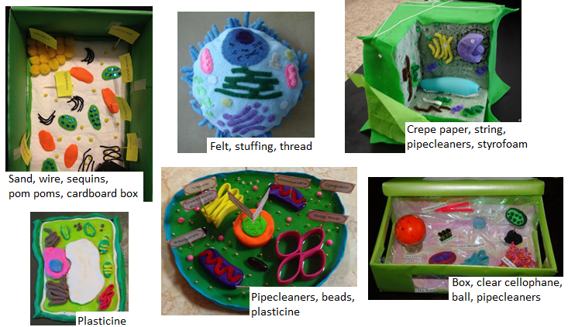*Below are some examples you can get ideas from.*

Cell model is unique and uses original ideas. (2 marks)

Cell model includes all listed structures for chosen cell type. (2 marks)

Cell structures in model resemble structures in actual cell. (2 marks)

Cell model is completed. (1 mark)

On this page draw a neat diagram of your cell model in lead pencil and label each cell structure using a ruler.

Diagram is completed in lead pencil. (1 mark)

Diagram is neat, an appropriate size and ruler is used to label. (1 mark)

All listed structures for appropriate cell are labelled. (1 mark)

Fill in the table below with six structures in your chosen cell (plant or animal) and the functions of each structure (in your own words, **not** copied from the booklet or another source!) (12 marks)

|  |  |
| --- | --- |
| **Cell structure (organelle)** | **Function** |
| **_______________________**  **_______________________** | ___________________________________________________________________________  ___________________________________________________________________________  ___________________________________________________________________________ |
| **_____________________**  **_____________________** | ___________________________________________________________________________  ___________________________________________________________________________  ___________________________________________________________________________ |
| **_______________________**  **_______________________** | ___________________________________________________________________________  ___________________________________________________________________________  ___________________________________________________________________________ |
| **_______________________**  **______________________** | ___________________________________________________________________________  ___________________________________________________________________________  ___________________________________________________________________________ |
| **_______________________**  **_______________________** | ___________________________________________________________________________  __________________________________________________________________________  ___________________________________________________________________________ |
| **______________________**  **______________________** | ___________________________________________________________________________  ___________________________________________________________________________  ___________________________________________________________________________ |

**Part two: the history of cell biology**

The discovery of cells was made possible by the development of the microscope in the 17th century. In 1665, the English scientist Robert Hooke used a microscope to examine a thin slice of cork. Hooke described it as consisting of “a great many little boxes.” These “little boxes” reminded him of the cubicles or “cells” in which monks lived, so he called them cells.

What Hooke had observed were actually the remains of dead plant cells. The first person to observe living cells was a Dutch trader, Anton van Leeuwenhoek. Although van Leeuwenhoek’s microscope was rather simple, in 1673 it was powerful enough to enable him to view the world of microscopic organisms which had never before been seen.

About 150 years passed before scientists began to organize the observations begun by Hooke and van Leeuwenhoek into a unified theory known as the cell theory.

This theory has three parts:

(1) All living things are composed of one or more cells.

(2) Cells are the basic units of structure and function in an organism.

(3) Cells come only from the reproduction of existing cells.

1. Explain what allowed scientists to discover the existence of cells. (2 marks)

_________________________________________________________________________________________________

_________________________________________________________________________________________________

_________________________________________________________________________________________________

_________________________________________________________________________________________________

2. State the name given to the small rooms that monks lived in. (1 mark)

_________________________________________________________________________________________________

3. Describe what Hooke observed when looking at a thin slice of cork. (1 mark)

_________________________________________________________________________________________________

_________________________________________________________________________________________________

4. Describe the discovery that van Leeuwenhoek made. (2 marks)

_________________________________________________________________________________________________

_________________________________________________________________________________________________

_________________________________________________________________________________________________

_________________________________________________________________________________________________

Early evidence for the cell theory was provided by German scientists. In 1838, the botanist Matthias Schleiden concluded that all plants are composed of cells. A year later, the zoologist Theodor Schwann came to the same conclusion about animals. In 1855, Rudolf Virchow, a physician who had been studying how disease affects living things, reasoned that cells come only from other cells. Over the years, modern scientists have gathered much additional evidence that strongly supports the cell theory.

5. The figure below indicates events that led up to the cell theory. (10 marks)

Complete the table by filling in the blank spaces. You can find **ALL** the information throughout this booklet.

|  |  |  |
| --- | --- | --- |
| Date | Scientist | Discovery |
|  |  | Observed the remains of dead plant cells. |
|  | Anton van Leeuwenhoek |  |
|  | Matthias Schleiden |  |
|  |  | Stated that all animals are made of cells. |
| 1855 |  |  |

Presented neatly and clearly. (1 mark)

Correct grammar and spelling. (1 mark)

Total mark: /40

Percentage: %

Teacher’s comments:

__________________________________________________________________________________________________________

__________________________________________________________________________________________________________

__________________________________________________________________________________________________________